**23-07-2024 (JAVA:CSA0983)**

**EXERCISE:1**

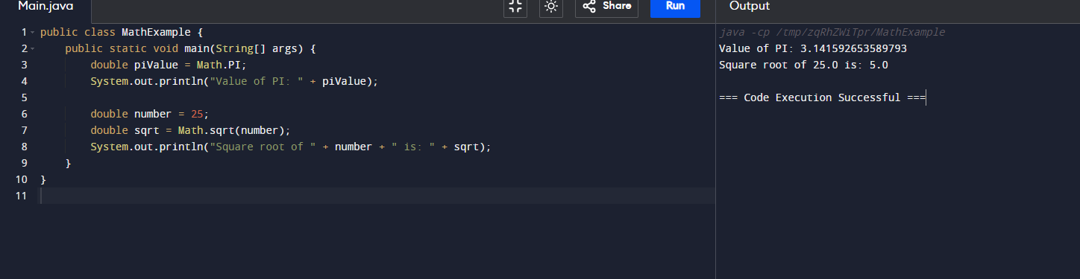

**EXERCISE:2**

**EXERCISE:3**

